How to make your organisation self-sustaining
Tafika Community Forest – Case Study
All Community Based Organisations struggle with money. Here is how Tafika Youth Organisation aim to make their organisation financially sustainable.
Tafika were new to forestry and took advice from the Malawi Department of Forests, Chinteche based, Ripple Africa and UK based forestry expert Andrew Heald. They planted a 30-acre community forest with fast growing pine trees (Pinus Oocapa). These trees take about 12-15 years to grow to maturity and will be harvested 2 acres at a time generating around $70-100,000 a year. The trees re-shoot so the forest is always re-growing, and with 30 acres it means Tafika can enjoy the benefits of cropping 2 acres a year for ever.
With widespread deforestation and an exploding population (Malawi’s population doubled in the last 20 years) the local community desperately need quality timber for building and roofing houses and they also need firewood as almost all Malawians are still forced to cook with wood. This commercial forest helps fulfil local demand and educates the community on the value of forestry.
To pay for the land and Tafika asked investors to lend them $28,000 in return for getting fully grown trees in 12-15 years’ time, the more money the investor gave the more trees they will receive in future. In this way Tafika didn’t need to have its own capital to start the project. Tafika volunteers cleared the land, created a tree nursery next to the Tafika Office and grew and planted the seedlings in order to keep costs down.
Trees need a lot of looking after in the first two years of life and a large forest also needs security to make sure the trees are not stolen or set on fire. Tafika didn’t have the cash to pay for labourers or security guards for 12-15 years while they waited for their trees to grow. To solve this they worked with Mzuzu based agribusiness MTF who provided training and $18,000 of funding for three polytunnel greenhouses. US based water NGO, Formidable Joy, contributed by provided funding for a borehole to be built at the site.
The greenhouses are owned by Tafika but each greenhouse is managed by a team of five women. Each woman works 2-4 hours a week in the greenhouse growing Grade A tomatoes, with each greenhouse producing two crops a year. MTF signed a distribution deal with Tafika and come to the greenhouses to buy all the tomatoes the women produce, at a fixed rate. Tafika reserve some of the revenue to pay for the guard and to build a fund for maintenance. Each woman involved will make around $4-500 a year from their share of the tomato sales.
In return for being given this opportunity the women agreed to give up 2-3 hours a week to weed and trim trees in the forest. In this way Tafika have created a sustainable, zero cost mechanism to maintain their forest, while at the same time providing 15 women with sustainable livelihoods. One of Tafika’s other project partners (ZMCP) liked the plan so much they provided $3,000 to fund a fourth greenhouse and Tafika successfully applied for a sensitive development loan from NGO Lend with Care to build a fifth greenhouse.
Tafika plan to use surplus income from these five greenhouses to save to buy another, and have worked out they have room for 10 greenhouses on the site. This will eventually provide 50 women with a sustainable income, while at the same time ensuring the Tafika forest is well maintained.
Tafika’s Director, Shupo Kumwenda said “We are so happy with our forest project, not only will this be a massive benefit to our community in years to come, but right now our youth volunteers have started to understand the value of trees not only to the local environment but also in terms of what their future value can bring to the community. We want to thank our partners for their efforts, we can see our future right here now.”
Kevin Simpson from MTF said "Tafika are showing a great way forward for Community Organisations in Malawi. We are delighted to work with them because they share our vision to see Malawians empowered to earn their own living and secure a sustainable future for themselves. This kind of long-term thinking and careful investment is exactly what Malawi needs. Well done everyone at Tafika!"
Cindee Rood from Formidable Joy said “Formidable Joy, a U.S.-based water NGO, continues to support Tafika's vision. We drilled a new borehole for the project, complemented by the installation of a solar pump by Malawi Fruits.
This marked the 29th water source donated by Formidable Joy. 20 new boreholes have been drilled and 9 pumps repaired in schools, villages, and health centre within Tafika's catchment area.
In 2023, Formidable Joy further contributed by funding a district-wide Cholera educational outreach campaign led by Tafika, which included the distribution of preventative supplies during the deadliest Cholera outbreak in the history of the country.”

Key takeaways:
For $49,000 Tafika will have created 26 permanent jobs and will have planted 30 acres of trees. This will create $70-100,000 of revenue for Tafika each, and every, year from 2036, securing the organisations financial future.
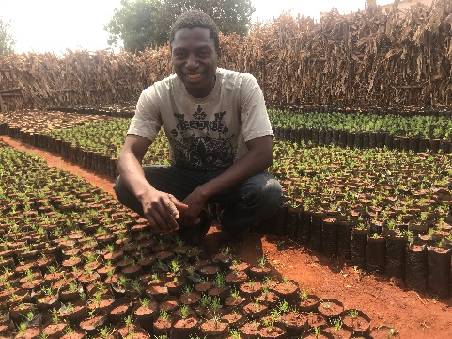 | 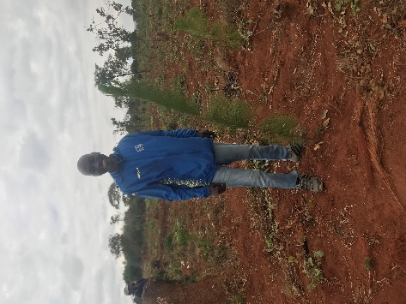 | 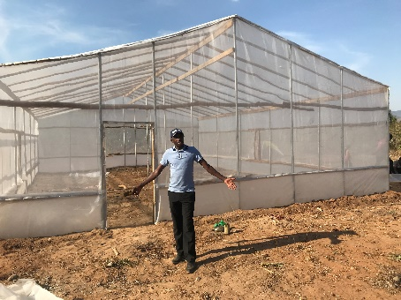
Tafika volunteer, Major, who manages the nursery, has managed grow 9,000 seedlings this year | Tafika Agricultural Manager Malumbo Muntali stands next to one of the 14,000 2-year-old trees already in the Tafika forest | Tafika Director Shupo Kumwenda stands in front of one of the greenhouses being erected by MTF.
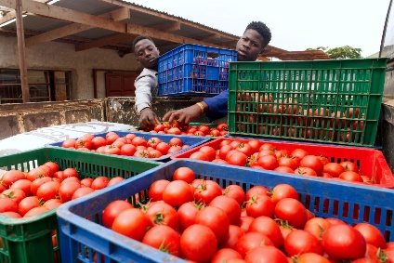 | 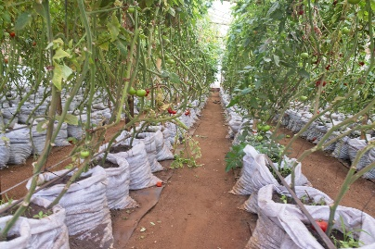 | 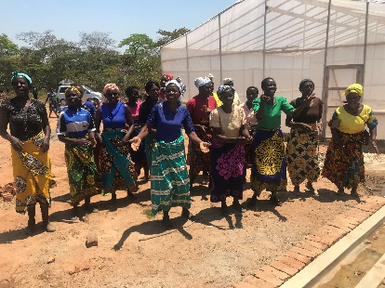
Grade A tomatoes being grown at other MTF sites | The inside of a tomato greenhouse in full production | The first set of women to benefit from the MTF greenhouses

